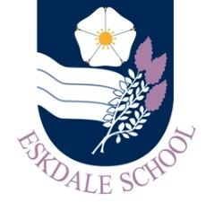
Our Curriculum: Technology
Our Intent
As a result of our curriculum, Eskdale School students will be inspired to:
- be innovative and passionate when designing and making, to critique the merits of technology and to develop skills for life.

Our Implementation
In order to realise our vision, our curriculum will provide students with the opportunities to:
- engage in hands on learning in well-resourced workshops, ICT suites and kitchens
- view high level exemplar design and making which shows them what they are truly capable of
- develop underlying knowledge of the theory that clearly relates to the practice taking place
- see their teachers modelling best practice, whether designing, making, programming or cooking
- work alongside teachers who actively challenge and support them to achieve their potential
- question the very idea of technological development using real world examples that encourage them to express their views and debate issues with passion
- develop lifelong practical skills that will enable them to cook, repair, program, design and make in their lives outside of Eskdale School
- engage in educational visits where they get to see the subject in real life, therefore leading to greater understanding and exposing them to the potential jobs, careers or further education opportunities available to them
- develop the knowledge, understanding and skills that will enable them to pursue their dreams and ambitions beyond their Eskdale school journey

The Impact
The impact of our curriculum will be evidenced in:
- our students’ enthusiasm for the subject which is displayed both in and out of the classroom
- our students’ work and their progress as evidenced in their practical, design, written and oral work
- the increased number of students taking Technology subjects in KS4
- the progress and attainment of students in external exams

Above all, our students are aware that technology is integral to life in our modern world. They are keen to push the boundaries, try out new ideas, take a critical view and apply their skills in imaginative ways. They are able to see the bigger picture, viewing themselves as positive users of technology whilst also being critical of its possible impact on the world, both positive and negative.

