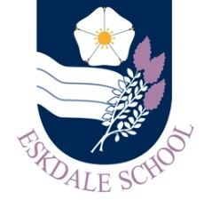
Our Curriculum: Science and PE
Our Intent
As a result of our curriculum, Eskdale School students will be inspired to:

- Engage with science and PE to build their skills and knowledge of the subjects which will inspire them to take this further.
- Deepen their thinking and questioning of the world around them ensuring that they can evaluate the impact they have on their community.

Our Implementation
In order to realise our vision, our curriculum will provide students with the opportunities to:

- Gain and develop practical skills in the lab and out on the field to allow team work to flourish
- Engage in inspiring lessons that deepen thinking across all science and PE areas
- Build new skills in subject areas that extends their previous understanding
- Question and evaluate their decisions during lessons to deepen understanding and challenge
- Engage with hands on practical lessons to explore the curriculum content
- Take part in additional events, for example science week, world environment day, STEM clubs, sports clubs or representing the school through sports

The Impact
The impact of our curriculum will be evidenced in:

- Students will show enthusiasm for learning in and outside the classroom
- Students will demonstrate progress over time in their work
- Students will look to take a science, PE or child development subject further at KS5
- Progress will be evident in data and external exam results
- Students will have developed the skill to question information they are given and to evaluate this before making choices about how to live their lives and the impact they will have on others

