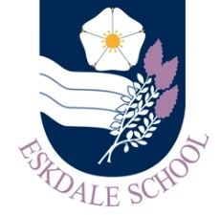
Our Curriculum: Religious Studies
Our Intent
Through our curriculum, Eskdale School’s PTE Department aspires to:
- develop a deep love of Religious Studies and learning
- explore a range of different beliefs and traditions that affect people all over the world
- develop a tolerance and acceptance of different beliefs and cultures
- become independent learners, critical readers and thinkers
Our Implementation
In order to realise our vision, our curriculum will provide students with the opportunities to:
- experience engaging and challenging lessons focusing on the development of transferable skills
- study a range of topics that appeal to a wide range of interests and impact on the world in which they live
- work alongside staff committed to ensuring they acquire the knowledge, understanding and skills that see them fulfil their potential in Religious Studies and help raise their aspirations
- analyse religious beliefs and scripture
- identify key beliefs and practices; develop the skills to be able to support these with specific scripture
- develop their enthusiasm and passion for Religious Studies, deepening their learning as they progress through school and beyond
- work independently to acquire and secure specific knowledge and supporting detail
- debate with confidence their own ideas and opinions, taking account of differing points of view and beliefs
- develop their recall skills so that their knowledge increases over time and they become confident in their knowledge base and their ability to apply this in their own work
The Impact
The impact of our curriculum will be evidenced in:
- our students’ enthusiasm for the subject which is displayed both in and out of the classroom
- our students’ work and their progress as evidenced in their books
- the increased number of students taking Religious Studies in KS4 and KS5, and beyond; the progress and attainment of students in external exams

Above all, our students are aware that British society and the global world in which they live is diverse; respect should be given to all.

