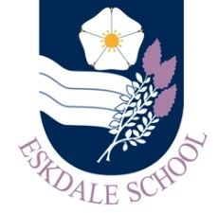
Our Curriculum: PSHE
Our Intent
Through our PSHE curriculum, Eskdale School’s PSHE department aspires to help students:
- become effective members of their local and national community; who can navigate their diverse world with empathy and compassion
- become successful adults and encourage them to make educated/informed decisions that will benefit them and those around them
- effectively assess risks within their lives and make positives decisions to keep themselves and others safe and healthy
- effectively navigate complex relationships; developing skills to assess healthy and unhealthy relationships so they are protected against dangerous behaviours
- aspire to achieve within their school careers and create lifelong aspirations for themselves within the world of work
Our Implementation
In order to realise our vision, our curriculum will provide students with the opportunities to:
- explore the meaning of an effective citizen; the interconnections of democracy, citizen involvement, UK law and the justice system
- investigate our diverse British and Global society; correcting misconceptions and critically thinking about how discrimination can be challenged
- reflect on the importance of positive relationships within their lives and develop skills to assess risky relationship activities and how to avoid or get support due to dangerous behaviours
- explore themes surrounding risking behaviours and form an understanding of dangerous situations; so skills can be developed in risk evaluation
- investigate their options after school in education and careers; develop enterprising and business skills
- explore positive lifestyle choices that will benefit their health and prevent future health risks; both physical and mental
The Impact
The impact of our curriculum will be evidenced in:
- our students’ work and their progress as evidenced in their books
- pastoral data on disclosures
- students use of pastoral support systems; such as the school nurse, councillors, LGBTQ+ Lead, Metal Health Lead and Safeguarding Lead
- student Feedback Questionnaires

Above all, our students are aware that the world in which they live is expansive, diverse and inspiring; they understand that they are members of a diverse, global community and appreciate that this brings both privileges and responsibilities.

