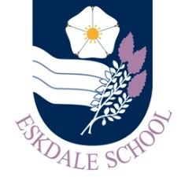
Our Curriculum: MFL
Our Intent
Through our curriculum, Eskdale School’s Languages Department will:
- inspire pupils to understand and communicate confidently and effectively in a foreign language
- have an increased sense of belonging to the wider world and to learn about life and culture in the countries in which the language they learn is spoken
- engage in developing the skills needed to learn a language and understand how these skills can be applied to all aspects of learning

Our Implementation
In order to realise our vision, our curriculum will provide students with:
- an engaging and inspirational curriculum delivered through engaging and exciting lessons
- lessons that are fun but always challenging
- a curriculum that is clearly structured to allow progression
- every opportunity to make language learning real and relevant by bringing the wider world into the classroom
- a focus on creativity and encouraging students to “play” with the language they learn
- resources that provide support and structure to enable students to communicate confidently
- work in classroom environments that are conducive to effective language learning

The Impact
The impact of our curriculum will be evidenced in:
- the enthusiasm with which students engage in their learning
- the creative and challenging outcomes in their exercise books and internal assessments
- the numbers of students continuing to study a language at KS4
- progress and attainment in external exams

