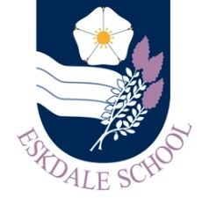
Our Curriculum: History
Our Intent
Through our curriculum, Eskdale School’s History Department aspires to:
- present the study of History in a logical, structured and chronological fashion
- teach students an appreciation of the history of the local area, of Britain and beyond
- inspire students’ curiosity to know more about the past
- increase students understanding of where they belong in time and in history, knowing what came before and pondering what could come next, therefore opening pathways to future careers and opportunities
- equip pupils with an understanding and practical use of the second order concepts - continuity and change, cause and consequence, similarity, difference and significance, etc.
- allow pupils to fully engage with skills in order to ask questions, investigate an outcome and form an argument

Our Implementation
In order to realise our vision, our curriculum will provide students with the opportunities to:
- engage in lessons with high quality explanations, modelling, explicit teaching of subject specific terminology and scaffolded practice to enable the development independent skills of oracy
- develop the skills of historical enquiry through questioning, investigation and critical thinking about issues that affected the past and the lives of people both then and now
- explore a diverse range of places and people to understand how societies, governments, economies and histories are interconnected
- explore local history through a variety of perspectives

The Impact
The impact of our curriculum will be evidenced in:
- our students’ work and their progress as evidenced in their work booklets through a range of assessment opportunities
- the high number of students taking History in KS4
- the progress and attainment of students in external exams at KS4
- Above all, our students are aware that the world in which they live is expansive, diverse and inspiring; they understand that they are members of a diverse, global community, with a wide and varied history

