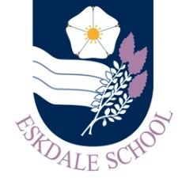
Our Curriculum: Creative Arts
Our Intent
As a result of our curriculum, Eskdale School students will be inspired to:

- Develop skills to express themselves creatively, independently & collaboratively.

Our Implementation
In order to realise our vision, our curriculum will provide students with the opportunities to:

- Perform, compose and produce
- Explore personal interests, contextual references and issues past and present in society
- Interpret the work of others creatively across difference genres and styles
- Develop a range of imaginative skills for expression relevant to the performing and visual arts

The Impact
The impact of our curriculum will be evidenced in:

- Our students’ enthusiasm for the subjects, which is displayed both in and out of the classroom
- Discussions with students about successful lessons and what is working to increase engagement
- Strong outcomes in exams and coursework
- Students can talk articulately about the subjects and their experiences with knowledge, confidence and integrity

