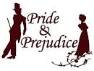
Watch This!

Classics
Pride and Prejudice pg
Parades End 15
Swallows and Amazons pg
The Age of Innocence U
A Room with a View U
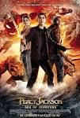
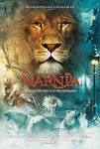
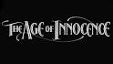
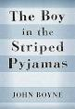
The Remains of the Day U

Greek / Roman Mythology
Ben Hur pg
Spartacus pg
Jason and the Argonauts pg
The Clash of the Titans 12
Percy Jackson and the Olympians pg
Percy Jackson Sea of Monsters pg
Troy 15
The Story Teller - Greek Myths (Amazon) u
Beowulf pg13

Dystopian
Hunger Games / Catching Fire / Mockingjay 12-15
Maze Runner / Scorch Trials / Death Cure 12-15
Divergent / Allegiant / Insurgent 12-15
Mortal Engines 12A
Fahrenheit 451 15
1984 pg

Fantasy
Harry Potter pg to 12A
The Hobbit 12
Lord of the Rings Series 12
His Dark Materials pg (New BBC series, 3rd November – iPlayer)
The Chronicles of Narnia pg
Skellig pg
War of the Worlds pg (New BBC series, iPlayer)

War
The 12th Man 15
Diary of Anne Frank 12
The Book Thief pg-13
The Great Escape pg
Empire of the Sun pg
Schindler’s List 15
Dunkirk 12
Saving Private Ryan 15
Hope and Glory 15
Gallipoli pg
Letters from Iwo Jima 15
Atonement 15

18th and 19th Century
Sherlock Holmes pg13
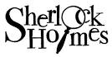
Alias Grace 15
North and South 12
The Mill 12 (Amazon)
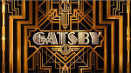
Anne with an E 12 (Based on Anne of Green Gables)
Titanic 12
Les Miserables (BBC series 12-15)
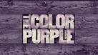
American / American History
Gatsby 12
12 Years a Slave 15
The Color Purple 15
BlacKkKlansman 15
The Last of the Mohicans 12
Little Women U
The Grapes of Wrath 12
The Outsiders 12
Stand By Me 15

Gothic
The Woman in Black 15
Jane Eyre (pg to 15 depending on adaptation)
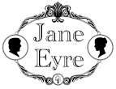
Sleepy Hollow 12
Picnic at Hanging Rock pg

BBC Dickens (all pg)
A Christmas Carol (Christmas 2019)
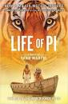
Great Expectations 2013 or any film adaptation
Our Mutual Friend 1998
Martin Chuzzlewhit 1984
Bleak House 2005
Little Dorrit 2008
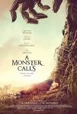
Oliver Twist 1948

BBC Jane Austin (all pg)
Persuasion
Emma
Pride and Prejudice
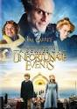
Northanger Abbey
Sense and Sensibility

Others
The Life of Pi pg
A Monster Calls 12A
A Series of Unfortunate Events pg (Netflix series or film)
The Hate U Give 12

