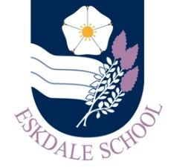
Our Curriculum: MATHS
Our Intent
As a result of our curriculum, Eskdale School students will be inspired to:
- engage positively with Mathematics and appreciate why Mathematics is important to both themselves and the wider world around them.
Our Implementation
In order to realise our vision, our curriculum will provide students with the opportunities to:
- embed, develop and deepen the knowledge, understanding and skills they have acquired in their study of Maths in primary school
- build on their prior knowledge so that all are able to progress from their individual starting points and experience success
- experience engaging and purposeful lessons that are characterised by pace, stretch and challenge
- develop their knowledge, fluency and application within Mathematics
- work alongside staff committed to ensuring they acquire the mathematical knowledge and skills that see them fulfil their potential and help raise their aspirations
- acquire the skills and knowledge to perform practical calculations as well as the application to solve more in-depth or abstract problems
- study a curriculum that is continually reviewed to ensure that it is fit for purpose
- have an experience that is consistent across the department and offers a high standard of teaching so that they are given the best opportunity to succeed

The Impact
The impact of our curriculum will be evidenced in:
- our students’ enthusiasm for the subject
- our students’ work and their progress as evidenced in their books
- the number of students taking Maths in KS5 and beyond
- the progress and attainment of students in external exams
Above all, our students leave us as numerate individuals, logical thinkers and “can do” problem solvers; they are equipped with resilience, a growth mindset and ready to succeed in their chosen careers.

