

***Hello Year 11 Geographers,***

**If you are considering Geography A-Level next year or are just interested in continuing to develop your geography knowledge over the coming weeks, why not use this time to explore the subject a little more. These pages are just ideas that you can dip in and out of as much as you like or use as a starting point to find other resources you find interesting – Enjoy!**

**WHAT TO WATCH?**

**THE ECONOMIST VIDEOS**

[**https://www.youtube.com/user/EconomistMagazine/videos**](https://www.youtube.com/user/EconomistMagazine/videos)

E.g. ‘Mangroves: How they help the ocean?’ and ’Can you insure against climate change?’

**TED TALKS**

[**https://www.ted.com/talks?sort=newest&topics%5B%5D=Global+issues**](https://www.ted.com/talks?sort=newest&topics%5B%5D=Global+issues)

**SIR DAVID ATTENBOROUGH BOX SETS**

[**https://www.bbc.co.uk/iplayer/group/p06m42d9**](https://www.bbc.co.uk/iplayer/group/p06m42d9)

**OPEN LEARN**

The Open University have a huge number of free online courses that you can study. They tell you how long they take and give an outline of what is included. You also get a free statement of participation on completion. Take a look and see if any take your interest. Some recommended ones linked to the A Level course are listed below:

[**https://www.open.edu/openlearn/nature-environment/the-environment/environmental-science/managing-coastal-environments/content-section-0?active-tab=description-tab**](https://www.open.edu/openlearn/nature-environment/the-environment/environmental-science/managing-coastal-environments/content-section-0?active-tab=description-tab)

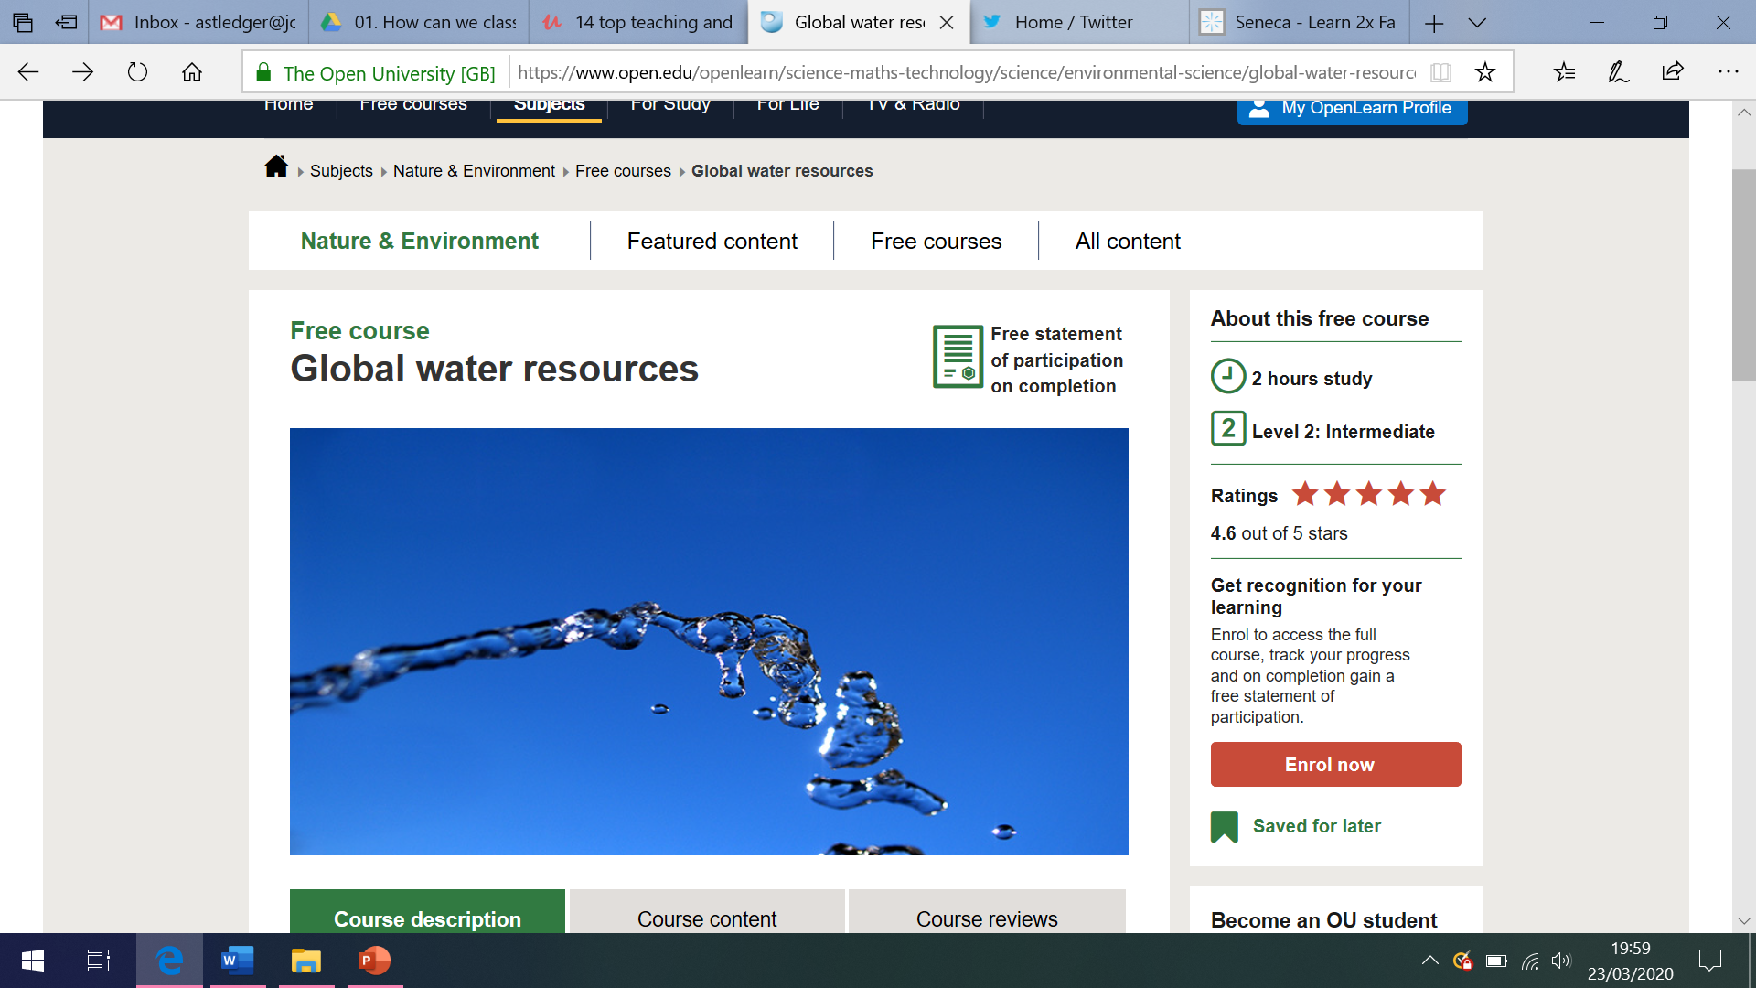

[**https://www.open.edu/openlearn/science-maths-technology/science/environmental-science/global-water-resources/content-section-0?active-tab=description-tab**](https://www.open.edu/openlearn/science-maths-technology/science/environmental-science/global-water-resources/content-section-0?active-tab=description-tab)

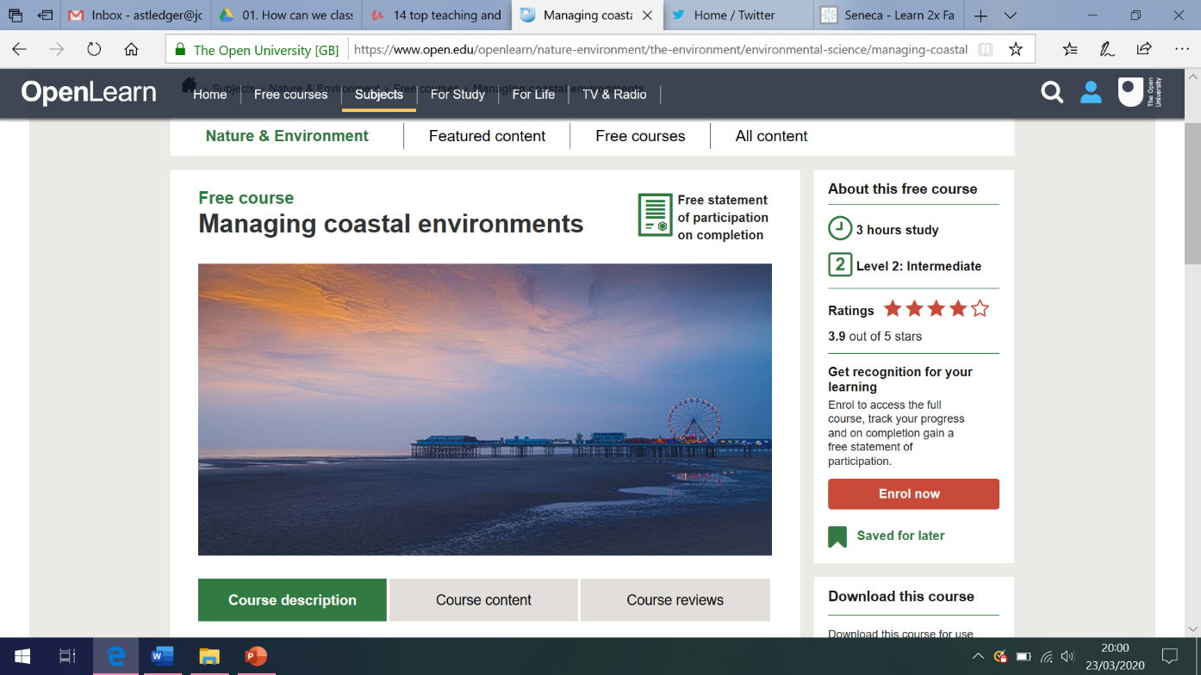



**UNDRR STOP DISASTER EMERGENCY PLANNING GAME**

[**https://www.stopdisastersgame.org/stop_disasters/**](https://www.stopdisastersgame.org/stop_disasters/)

UNDRR stands for the UN Office for Disaster Risk Reduction. This online game aims to teach you how to build safer villages and cities against disasters. You will learn how the location and the construction materials of houses can make a difference when disasters strike and how early warning systems, evacuation plans, and education can save lives. You are the future architects, mayors, doctors, and parents of the world of tomorrow. If you know what to do to reduce the impact of disasters, they will create a safer world.

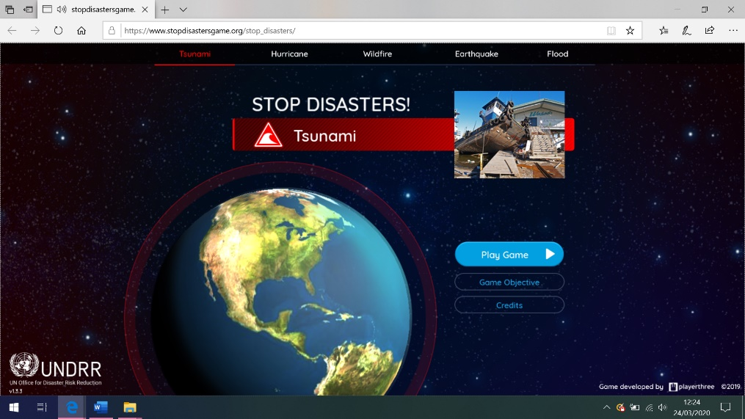

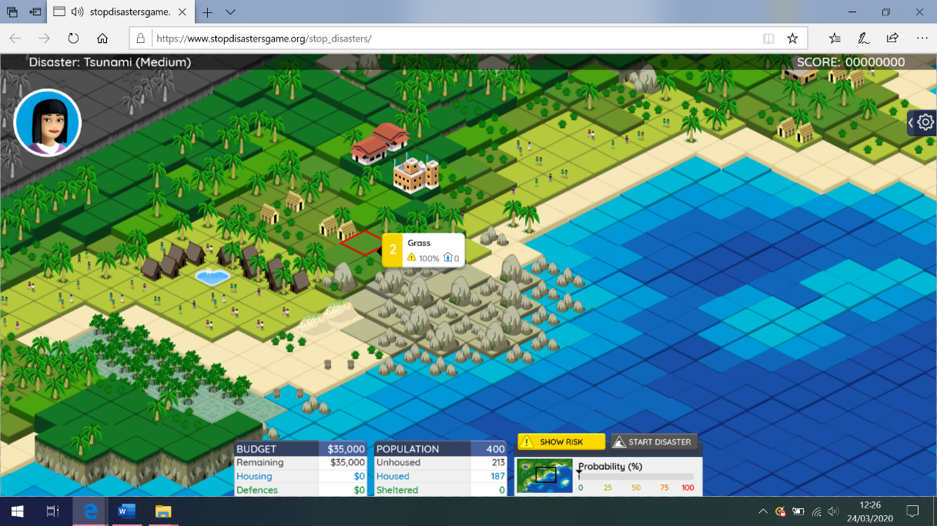



**LA TIMES CLIMATE CHANGE RISING OCEANS GAME**

[**https://www.latimes.com/projects/la-me-climate-change-ocean-game/**](https://www.latimes.com/projects/la-me-climate-change-ocean-game/)

The sea is rising higher and faster — California could see a jump of more than 9 feet by the end of the century. Flooding and erosion threaten homes. Beaches could vanish. But everyone insists: This is a game that can be won.

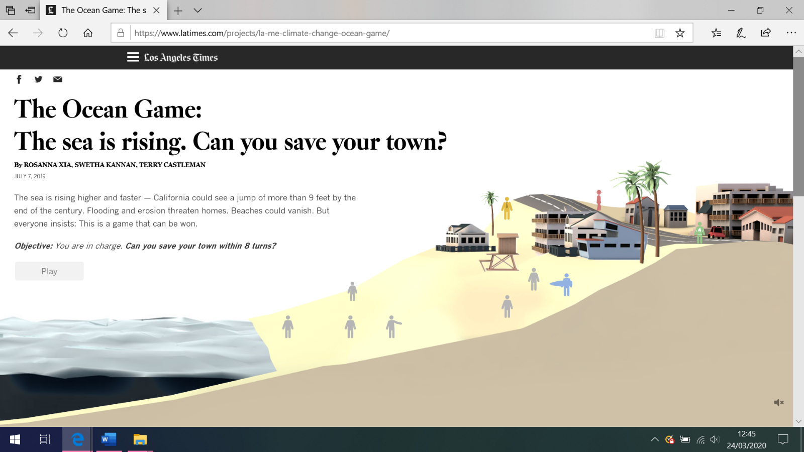

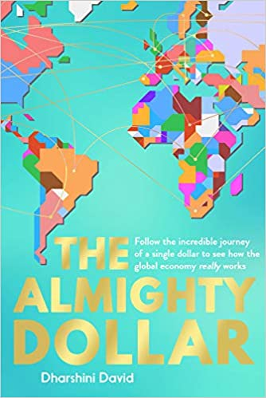

**WHAT TO LISTEN TO?**

Search for these Podcasts on

your phone!

**THE ECONOMIST PODCASTS**

[**https://www.economist.com/podcasts/**](https://www.economist.com/podcasts/)

**ASK THE GEOGRAPHER – Royal Geographical Society**

[**https://www.rgs.org/schools/teaching-resources/ask-the-expert-podcasts/**](https://www.rgs.org/schools/teaching-resources/ask-the-expert-podcasts/)

*You can then listen on Soundcloud or iTunes*

‘Hazards and volcanic gas emissions’ with Dr Tom Pering, ‘Forests and the Carbon Cycle’ with Professor Rob

MacKenzie and

Professor Jerry

Pritchard, ‘Extreme

weather in the UK;

past, present and

future’ with Professor

Georgina Endfield.

**WHAT TO READ?**

Darshini David -

[**The Almighty Dollar**](https://www.amazon.co.uk/Almighty-Dollar-Incredible-Journey-Economy/dp/1783963980/ref=pd_sbs_14_1/260-9067559-2021302?_encoding=UTF8&pd_rd_i=1783963980&pd_rd_r=ef2ad0f6-54c8-4e5f-aff2-e69ef9c437db&pd_rd_w=ygSM6&pd_rd_wg=RJNSR&pf_rd_p=96cae456-8d7a-4bc1-91c7-9b20b4dfd7c9&pf_rd_r=YAE59EK6W111J69MPWY6&psc=1&refRID=YAE59EK6W111J69MPWY6)

Hans Rosling –

[**Factfulness**](https://smile.amazon.co.uk/Factfulness-Reasons-Wrong-Things-Better/dp/1473637465/ref=smi_www_rco2_go_smi_g5447869900?_encoding=UTF8&%2AVersion%2A=1&%2Aentries%2A=0&ie=UTF8)

Tim Marshall –

[**Prisoners of Geography**](https://smile.amazon.co.uk/Prisoners-Geography-Everything-Global-Politics/dp/1783962437/ref=sr_1_1?crid=2OFQ8NB8CG3CI&dchild=1&keywords=prisoners+of+geography&qid=1584704730&s=books&smid=A1G3UP32AZJ14F&sprefix=prison%2Cstripbooks%2C149&sr=1-1)

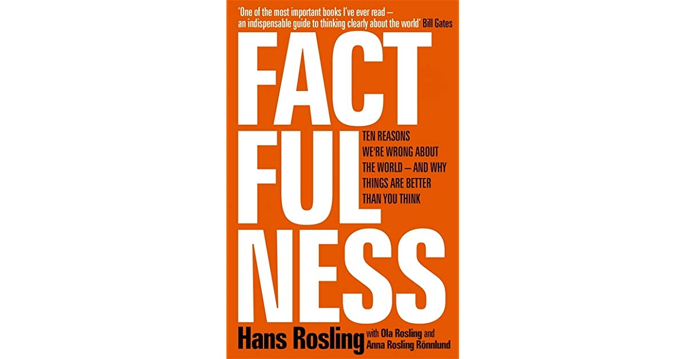

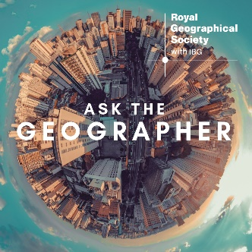

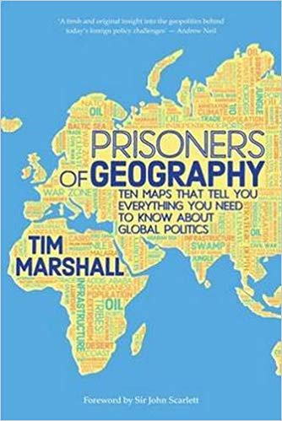

**EXPLORE CAREERS IN GEOGRAPHY**

Explore the links below to see

the further education and

career opportunities linked to

Geography!

Click the link below and at the bottom of the page click on the ‘***Going Places with Geography Brochure’*** link. Explore why Geography is so valuable to study, the skills you gain through your studies and how these can link to future careers.

[**https://www.rgs.org/schools/teaching-resources/going-places-with-geography-brochure/**](https://www.rgs.org/schools/teaching-resources/going-places-with-geography-brochure/)

The link below takes you to a

page where you can see

the huge range of jobs

geographers can go onto do!

[**https://www.rgs.org/iamageographer/**](https://www.rgs.org/iamageographer/)



**HOW TO IMPROVE YOUR GENERAL GEOGRAPHY KNOWLEDGE …**

Use Sporcle to see how good your country and capital city knowledge is.

Start with

Europe …

[**https://www.sporcle.com/games/g/europe**](https://www.sporcle.com/games/g/europe)

