Online fun with the Captain Cook Memorial Museum!
Hope you are all staying safe and well and finding things to do. We are missing our regular workshops at the Captain Cook Memorial Museum so we have been busy preparing activities for you to enjoy online.
We will be releasing things every week on our Facebook page Captain Cook Memorial Museum. Please like and follow our page to get regular updates and posts.
If you can’t access Facebook, please let me know if you would like to go on a regular email list of these activities
We will also be posting on
Twitter @CptCookWhitby
Instagram cookmuseumwhitby
Youtube Captain Cook Memorial Museum

Look out for the following and more…
Videos
Fun videos of things to do with the kids, including our first video ‘How to avoid Scurvy!’ (also on our Captain Cook Memorial Museum Youtube channel) https://www.youtube.com/watch?v=hT6Fa1lAhlM&t=8s
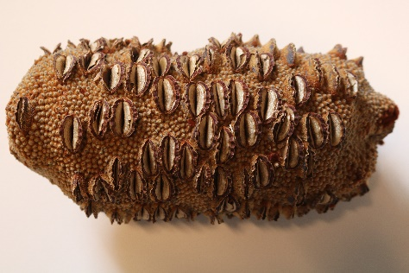
Intriguing Objects
We will be posting unusual objects relating to the museum. Take a close look and see if you can work out what they are. Send or post us your ideas, drawings and pictures
This week’s object

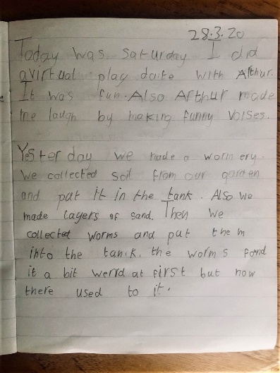
Lockdown journals
Captain Cook, kept journals every day on his voyages which helps us to learn about his adventures and encounters.
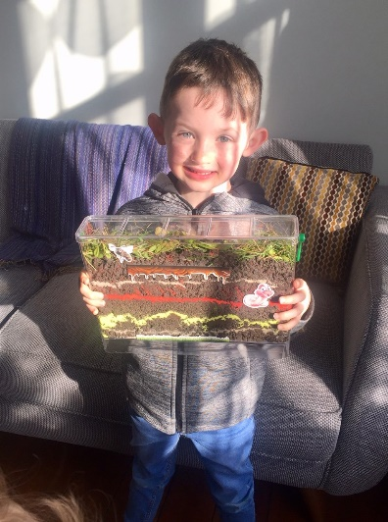
We would like you to write a journal page(s) telling us what you have been doing on your lock down and send it with a drawing or a photo. We will create an online gallery of these
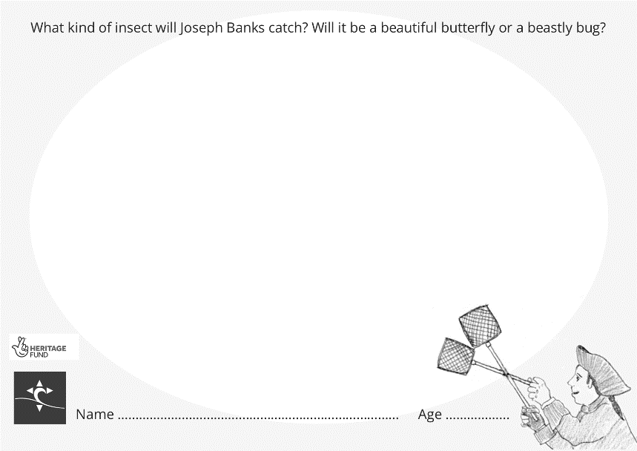
Download and Draw
Activity cards relating to the museum to download and fill in. These can then be reposted or sent to us for a gallery

​

